

Tribhuvan University
Faculty of Humanities and Social Sciences

8-PUZZLE GAME AND SOLVER

A PROJECT REPORT

Submitted to
Department of Computer Application
D.A.V. College

In partial fulfillment of the requirements for the Bachelors in Computer Application

Submitted by
Himal Subedi
[6-2-469-161-2020]
November, 2024

Under the Supervision of
Er. Nihal Shrestha

Tribhuvan University
Faculty of Humanities and Social Sciences
D.A.V. College

Supervisor’s Recommendation

I hereby recommend that this project, prepared under my supervision by HIMAL SUBEDI entitled “8-PUZZLE GAME AND SOLVER” in partial fulfillment of the requirements for the degree of Bachelors of Computer Application be recommended for the final evaluation.

Er. Nihal Shrestha
SUPERVISOR
Lecturer
Bachelors in Computer Application
Jawalakhel, Lalitpur



Tribhuvan University
Faculty of Humanities and Social Sciences
D.A.V. College

LETTER OF APPROVAL

This is to certify that this project prepared by HIMAL SUBEDI entitled “8-PUZZLE GAME AND SOLVER” in partial fulfillment of the requirements for the degree of Bachelors in Computer Application has been evaluated. In our opinion, it is satisfactory in the scope and quality as a project for the required degree.
Er. Nihal Shrestha  Lecturer  Bachelors in Computer Application  Jawalakhel, Lalitpur | Mr. Sudip Adhikari  Head Of Department  Bachelors in Computer Application  Jawalakhel, Lalitpur
Internal Examiner  Ms. Shrilata Wagle  Lecturer  Bachelors in Computer Application  Jawalakhel, Lalitpur | External Examiner  Mr. Roshan Tandukar  Asst. Professor  Tribhuvan University

ACKNOWLEDGEMENT

During the completion of this project, many individuals provided valuable guidance and support. I would like to express my sincere gratitude to everyone who contributed to this project.
I am grateful to Tribhuvan University for providing this opportunity. My gratitude extends to D.A.V. College for fostering an environment conducive to learning and providing the requisite infrastructure. I also wish to acknowledge Mr. Shashi Bhusan Chaturwedi, the BCA Department Coordinator, and Mr. Sudip Adhikari, our esteemed Department Head.
The indispensable guidance of Er. Nihal Shrestha has been a cornerstone, providing unwavering support and insightful direction throughout every project phase. This collaborative effort has undoubtedly shaped the project's success.
Lastly, I am compelled to express my heartfelt thanks to my parents and classmates whose unwavering support and assistance have been a constant throughout my journey in developing this project.

With Regards,
Himal Subedi
TU Registration No: 6-2-469-161-2020

ABSTRACT

This project focuses on developing a web-based application for the 8-Puzzle Game and Solver. The system allows users to engage with the classic 8-puzzle game, where they must arrange numbered tiles in a 3x3 grid in the correct order by sliding them into an empty space. Additionally, the application incorporates an intelligent puzzle solver using the A* algorithm, which can solve user-input puzzles and display step-by-step solutions. The primary goal is to offer an interactive platform for users to play the 8-puzzle game and observe how algorithms solve such problems in real-time.
The project includes various functionalities such as randomizing solvable puzzles, checking for puzzle solvability, manually inputting puzzle configurations, and visualizing the solution path. Tools such as XAMPP, Visual Studio Code, and a web browser are employed to develop this system. This project aims to enhance user understanding of problem-solving techniques and algorithms through an engaging and educational interface.
Keywords: Web-based Application, XAMPP, Visual Studio Code, 8-Puzzle Game and Solver, A* Algorithm

TABLE OF CONTENTS

ACKNOWLEDGEMENT i
ABSTRACT ii
TABLE OF CONTENTS iii
LIST OF ABBREVIATIONS v
LIST OF FIGURES vi
LIST OF TABLES vii
CHAPTER-1 INTRODUCTION 1
1.1 Introduction 1
1.2 Problem Statement 1
1.3 Objectives 2
1.4 Scope and Limitations 2
1.5 Report Organization 2
CHAPTER 2: BACKGROUND STUDY AND LITERATURE REVIEW 3
2.1 Background Study 3
2.2 Literature Review 3
CHAPTER 3: SYSTEM ANALYSIS AND DESIGN 5
3.1 System Analysis 5
3.1.1 Requirement Analysis 5
3.1.2 Feasibility Analysis: 7
3.1.3 System Flow 9
3.1.4 Process Modeling: 10
3.2 SYSTEM DESIGN: 12
3.2.1 Architecture Design: 13
3.2.2 Database Schema Design 14
3.2.3 Interface Design: 15
3.3 Description of Algorithm 17
CHAPTER 4: IMPLEMENTATION AND TESTING 19
4.1 Implementation 19
4.1.1 Tools Used 19
4.1.2 Implementation Details of Modules 19
4.2 Testing 22
4.2.1 Test Case for Unit Testing 22
4.2.2 Test Case For System Testing 27
CHAPTER 5: CONCLUSION AND FUTURE RECOMMENDATIONS 28
5.1 Conclusion 28
5.2 Lesson Learned Error! Bookmark not defined.
5.3 Future Recommendations 29
REFERENCE 30
APPENDICES 31

LIST OF ABBREVIATIONS

CSS - Cascading Style Sheet
DFD - Data Flow Diagram
ER - Entity Relationship Diagram
HTML - Hypertext Markup Language
IDE - Integrated Development Environment
JS - JavaScript
PHP - Hypertext Pre-Processor
SQL - Structured Query Language
VS - Visual Studio Code

LIST OF FIGURES

Figure 3. 1: Use Case Diagram of 8-puzzle Game and Solver 6
Figure 3. 2: Gantt Chart of 8-puzzle Game and Solver 8
Figure 3. 3: Flow Chart of 8-puzzle Game and Solver 9
Figure 3. 4: Level-0 Data Flow Diagram of 8-puzzle Game and Solver 10
Figure 3. 5: Level-1 Data Flow Diagram of 8-puzzle Game and Solver 11
Figure 3. 6: Iterative Waterfall Model of 8-puzzle Game and Solver 12
Figure 3. 7: Architecture Design of 8-puzzle Game and Solver 13
Figure 3. 8: Database Schema Diagram of 8-Puzzle Game and Solver 14
Figure 3. 9: Login Page Design of 8-puzzle Game and Solver 15
Figure 3. 10: 8-Puzzle Game 16
Figure 3. 11: 8-Puzzle Solver Design 16

LIST OF TABLES

Table 4. 1 Login Testing 22
Table 4. 2 Register and Forgot Password Testing 23
Table 4. 3 Puzzle Game Testing 24
Table 4. 4 Solver Testing 26
Table 4. 5 System Testing 267

CHAPTER-1 INTRODUCTION

1.1 Introduction
The 8-Puzzle Game and Solver is a dynamic web application designed to offer an engaging and interactive experience for enthusiasts of the classic 8-puzzle game. This application not only allows users to play the game by arranging the numbered tiles to reach the solved state but also provides a robust solver feature powered by the A* algorithm. With an intuitive interface, users can easily input their custom puzzle configurations and receive a step-by-step solution that demonstrates the optimal path to solve the puzzle. Whether for educational purposes or sheer enjoyment, this 8-Puzzle Game and Solver serves as a valuable tool for anyone interested in exploring problem-solving strategies and understanding the intricacies of the 8-puzzle challenge.

1.2 Problem Statement
Despite the enduring appeal of the classic 8-puzzle game, many enthusiasts find solving it manually to be both time-consuming and challenging. The traditional approach poses several difficulties: incorrect moves can lead to frustration, significant time and effort are required to manually find solutions, and the lack of a systematic strategy often results in suboptimal solutions, particularly for complex configurations.
The 8-Puzzle Game and Solver web application addresses these challenges by providing an interactive platform where users can play the game as well as solve it with ease and precision. Leveraging the powerful A* algorithm, the solver component of the application ensures that any solvable puzzle configuration is solved efficiently and accurately. This eliminates the risk of frustration due to incorrect moves. Additionally, the web-based nature of the application provides the convenience of solving puzzles from any device with a web browser and internet connection. The intuitive user interface and structured solving approach make it accessible and enjoyable for puzzle enthusiasts of all skill levels, enhancing both the gameplay and learning experience.

1.3 Objectives
The developed project allows users to play and solve 8-puzzle problems efficiently and accurately. It also eliminates the challenges associated with manual solving.The main objective of this project is:
- To develop a web-based 8-Puzzle Game and Solver application using A* algorithm

1.4 Scope and Limitations
The 8-Puzzle Game and Solver can be used in educational settings such as computer science departments, research institutes, and puzzle enthusiasts' communities. It serves as a tool for learning and teaching algorithms, problem-solving techniques, and artificial intelligence concepts. The system can be implemented in both academic environments and as a recreational web application, allowing users to either solve the puzzle themselves or observe the automated solver in action. Limitation of the project is:
- The system cannot provide hints or suggest optimal moves to help the user while playing the puzzle manually.

1.5 Report Organization
Chapter 1: This chapter provides an overview of the 8-Puzzle Game and Solver project, including its objectives and significance.
Chapter 2: This chapter explores existing systems and research related to 8-Puzzle Game and Solver to gain insights and knowledge.
Chapter 3: This chapter focuses on analyzing requirements and designing the 8-Puzzle Game and Solver.
Chapter 4: This chapter covers the implementation and testing phases of the 8-Puzzle Game and Solver.
Chapter 5: The final chapter summarizes the project's outcomes and presents recommendations for future enhancements.

CHAPTER 2: BACKGROUND STUDY AND LITERATURE REVIEW

2.1 Background Study
To ensure the development of an effective and user-friendly 8-puzzle game and solver application, it is important to consider the perspectives of both puzzle enthusiasts and researchers. Gathering insights from their experiences with traditional manual puzzle-solving methods, including their expectations, preferences, and pain points, can inform the design and functionality of both the game and solver components. Factors such as ease of use, gameplay experience, algorithm efficiency, solution accuracy, and user interface design are taken into consideration to create a system that caters to the needs of different types of users involved.
Overall, the background study reveals the need for an 8-puzzle game and solver application that addresses the limitations of manual solving methods and aligns with the increasing demand for engaging and accurate puzzle solutions. By leveraging technological advancements and understanding the context of puzzle-solving, an effective and user-friendly solution can be developed to ensure optimal gameplay, reduce solving time, and enhance the overall puzzle-solving experience for users.

2.2 Literature Review
Solver of 8-Puzzle with Genetic Algorithm [1] published in the Journal of Applied Technology and Innovation, explores the application of Genetic Algorithms (GA) to solve the 8-puzzle problem, a well-known problem in artificial intelligence and mathematics. The authors provide a comprehensive approach by implementing genetic algorithms, inspired by Charles Darwin's theory of natural evolution, to generate, evaluate, and evolve populations of potential solutions. Through modifying parameters such as crossover rate, mutation chance, and population size, the study demonstrates that higher crossover rates and mutation chances generally lead to faster problem-solving, while larger population sizes tend to increase the time required to find solutions. The research highlights the efficacy of genetic algorithms in finding optimal solutions for the 8-puzzle problem, although it acknowledges the trade-off in terms of computational time with varying parameter configurations.
Complete Solution of the Eight-Puzzle and the Benefit of Node Ordering in IDA* [2]. This paper presents exhaustive statistical data from evaluating all possible configurations, providing insights into solution lengths, the easiest and hardest configurations, and the distribution of solution nodes. Additionally, the paper examines the benefits of node ordering in the IDA* algorithm. The findings highlight that common IDA* implementations with fixed node ordering perform worse compared to a simple random ordering of operators.
Performance Analysis of Various Uninformed and Informed Search Strategies on 8 Puzzle Problems [3]. The research conducted by Vinay Menon and colleagues at Vellore Institute of Technology concluded that the A* algorithm is the most efficient for solving the 8-puzzle problem. By comparing various search strategies including Breadth-First Search (BFS), Depth-First Search (DFS), Hill Climbing, and Steepest Ascent Hill Climbing, they found that A* consistently required fewer node explorations and moves to reach the goal state. This efficiency is attributed to A*'s use of a combined heuristic that optimally balances the cost already incurred and the estimated cost to the goal. Their experiments demonstrated that while other algorithms sometimes failed to find a solution or took longer, A* reliably provided the best performance across different test cases.

CHAPTER 3: SYSTEM ANALYSIS AND DESIGN

3.1 System Analysis
System analysis involves a comprehensive evaluation of the 8-Puzzle Game and Solver to identify its functional and non-functional requirements, analyze user needs, and ensure efficient system performance. Through systematic examination and modeling of both the gameplay and puzzle-solving processes, system analysis aims to understand the existing algorithms, data flow, and user interactions to design an optimal and user-friendly solution. This analysis will help identify essential features such as puzzle input methods, game mechanics, visualization of solving steps, and performance metrics, ensuring that the application meets the needs of both casual players and advanced puzzle enthusiasts while providing an intuitive interface for a seamless user experience.

3.1.1 Requirement Analysis
Requirement analysis encompasses the identification and documentation of both functional requirements, which define the system's desired functionality, and non-functional requirements, which specify the system's performance, usability, and other quality attributes. It also includes various diagrammatic figures that let us understand the core backbone of the system and how it functions.
i. Functional Requirement
Functional requirements are crucial for a project as they define the specific features and behaviors the system must have to meet user needs and project goals. They serve as a roadmap for development, ensuring the system delivers the desired functionalities and outcomes. The functional requirements for this project are as follows:
i. User Login: To validate users and to track their progress.
ii. Puzzle Solving: To solve the given puzzle.
iii. Solution Visualization: To display step-by-step solution of the puzzle.
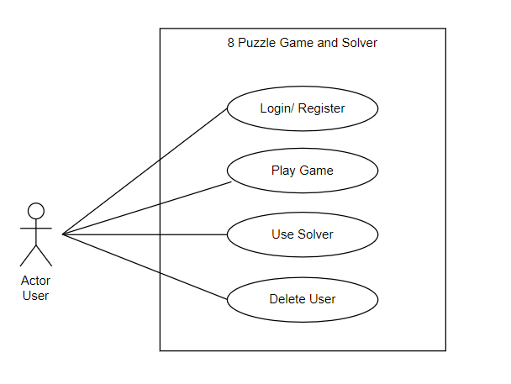
Figure 3. 1: Use Case Diagram of 8-puzzle Game and Solver

ii. Non-Functional Requirement
Non-Functional Requirements specify criteria that can be used to judge the operation of the system. Unlike functional requirements, non-functional requirements describe quality attributes and constraints of the system. The non-functional requirements in this project are:
- Usability: The system should have a user-friendly interface that is intuitive and easy to navigate, allowing users to input puzzle data conveniently.
- Reliability: The system should be reliable and available for use at all times, minimizing any downtime or disruptions in service.
- Performance: The system should be able to solve puzzle within a reasonable time frame.

3.1.2 Feasibility Analysis
- Technical Feasibility
The 8-Puzzle Game and Solver will be made using the following technically available resources:
- For frontend development:
- HTML
- CSS
- JavaScript
- For backend and data storage:
- PHP
- MySQL
As the above mention technology is readily available and sufficient for the project’s need. This project is technically feasible.
- Operational Feasibility
Operational feasibility is measured by how well the 8-puzzle game and solver will support both users and developers during its operational phases. This application enhances the puzzle-solving and gameplay experience by providing an engaging interface and efficient solutions to the 8-puzzle problem. By employing the A* algorithm, the solver component ensures optimal performance, meeting users’ needs for effective puzzle-solving while allowing developers to maintain high standards of software quality and usability. The user-friendly interface facilitates easy input, interactive gameplay, and visualization of solutions, making it accessible for both casual players and researchers, ultimately fostering a supportive environment for continued engagement with the puzzle-solving community.
- Economic Feasibility
An 8-Puzzle Game and Solver application can yield significant economic benefits for both casual users and educational institutions. First, it can reduce the time and effort associated with manually solving puzzles, allowing users to enjoy the game while also learning and applying problem-solving strategies without frustration from challenging configurations. Second, it can boost educational productivity by serving as a valuable teaching tool in mathematics and computer science courses, helping students grasp concepts related to algorithms. Third, the application increases accessibility and convenience, enabling users to play and solve the 8 Puzzle from anywhere with an internet connection, which is especially advantageous for remote learners and puzzle enthusiasts. Overall, implementing an effective 8-puzzle game and solver application can provide a strong return on investment for educational institutions and individual users alike, making it an economically viable solution for enhancing problem-solving skills, promoting engagement with computational thinking, and offering an enjoyable gaming experience.
- Scheduling Feasibility
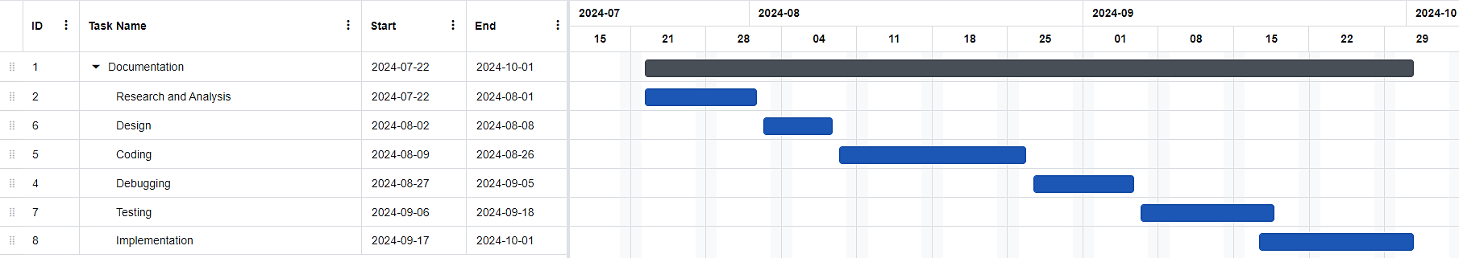
This includes the project schedule and time allocated for their completion. The Gantt chart for the project is: -
Figure 3. 2: Gantt Chart of 8-puzzle Game and Solver

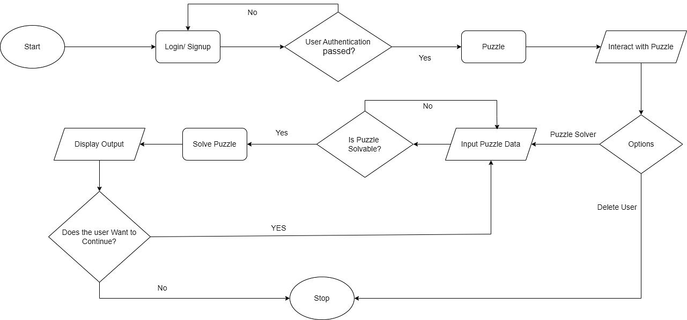
3.1.3 System Flow
Figure 3. 3: Flow Chart of 8-puzzle Game and Solver

This flowchart provides a clear picture of how the flow of operations occurs in the 8-Puzzle Game and Solver and how the system functions. The system begins with a login, guiding users through the authentication process and various other processes until they decide to close the application. It visually outlines each step, including the puzzle game, puzzle input, solving algorithms, and the display of results, ensuring a seamless user experience. This comprehensive view enhances clarity and facilitates better understanding of the system's functionality.

3.1.4 Process Modeling
Process modeling is the practice of creating visual representations that depict the sequence of activities, decisions, and interactions within a system The level 0 and Level 1 Data Flow Diagram for the project is in figure 3.4 and figure 3.5 respectively.
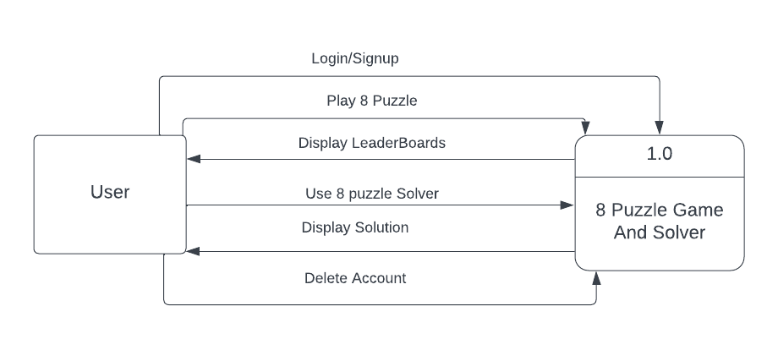
Figure 3. 4: Level-0 Data Flow Diagram of 8-puzzle Game and Solver
The Level 0 Data Flow Diagram shows how the user interacts with the 8 Puzzle Solver, the user is able to login/signup and after that is able to play the puzzle game or input puzzle data, which the 8 Puzzle Solver process and gives an appropriate response back. 8 Puzzle Game also displays the data of top user who completed the puzzle in the shortest of time. The user is also able to delete their account if they choose to do so.

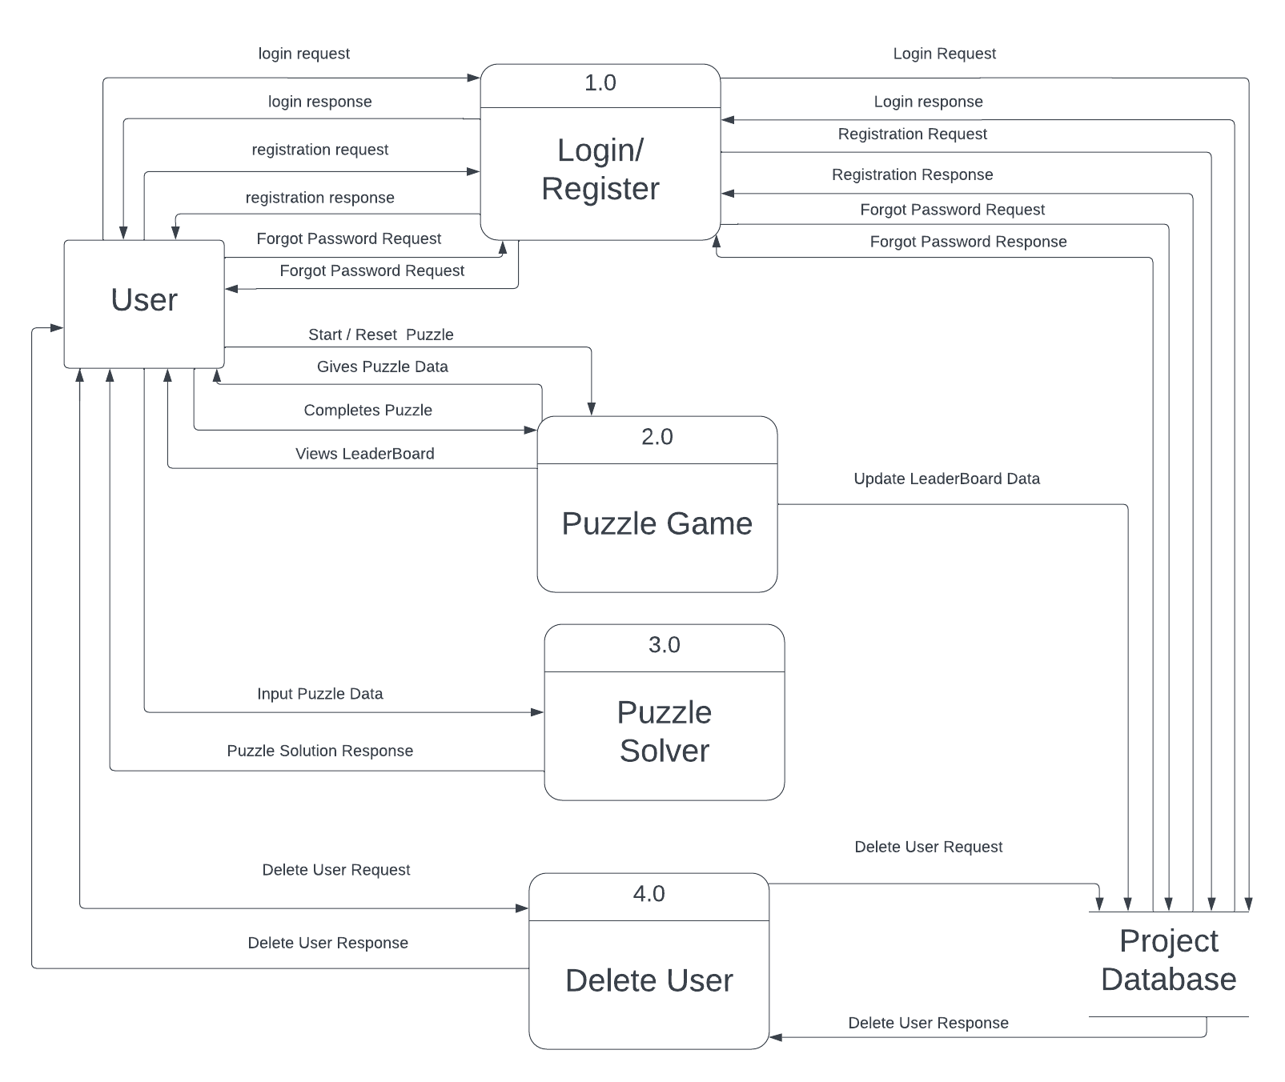
Figure 3. 5: Level-1 Data Flow Diagram of 8-puzzle Game and Solver
The level 1 DFD shows the various processes inside the 8 Puzzle Solver in detail. It shows how the data flows throughout the system and how each and every process communicate with the other processes and the database so the system as a whole can function properly and complete its intended use.

3.2 SYSTEM DESIGN
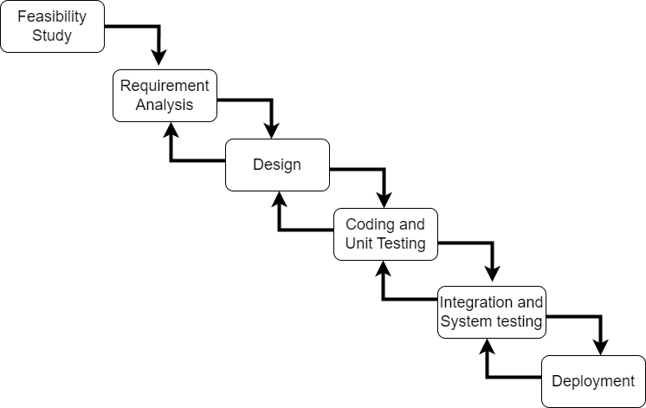
Figure 3. 6: Iterative Waterfall Model of 8-puzzle Game and Solver

The feasibility study phase ensured the project's viability by addressing the technical, operational, economic, and functional requirements of the 8-Puzzle Game and Solver. The requirement analysis phase comprehensively examines the necessary functionalities of both the game and solver and how they impact user interaction, gameplay experience, and problem-solving efficiency. During the design phase, decisions are made regarding the interactions between different modules, their functionalities, and the visual aspects of the application interface.
Coding was carried out using Visual Studio Code, and unit testing was conducted to ensure thorough testing of all project modules. The integration and system testing phase evaluated inter-module interactions, gameplay mechanics, and the overall performance of the game and solver. As a practical environment often reveals errors in each development phase, the iterative waterfall model is employed, allowing for error correction in earlier stages and providing a structured approach for the project’s development. Consequently, the iterative waterfall model was selected for the 8-Puzzle Game and Solver project.

3.2.1 Architecture Design
Architecture design involves creating a high-level blueprint that defines the structure, components, and interactions of a system. The architecture design for this project is in figure 3.7:
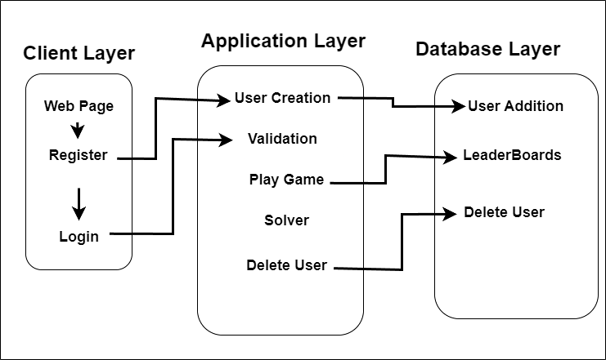
Figure 3. 7: Architecture Design of 8-puzzle Game and Solver
The Architectural Design Diagram illustrates the interaction between the different system layers, ensuring seamless functionality. The Client Layer represents the user interface, comprising various webpages through which users interact with the system. The Application Layer functions as a bridge, managing communication between the client interface and the underlying data processes. It handles the core logic and system operations. The Database Layer securely stores all critical information, such as user credentials and leaderboard data, ensuring efficient data retrieval and management. Together, these layers provide a cohesive and well-structured system.

3.2.2 Database Schema Design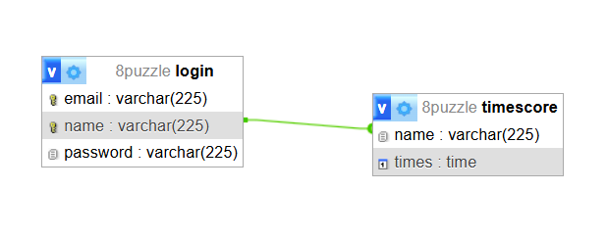
Figure 3. 8: Database Schema Diagram of 8-Puzzle Game and Solver
The Data Schema Diagram clearly illustrates the database structure for the 8-Puzzle Game and Solver Application. The database consists of two main tables: login and timescore. The login table stores user details, including email, name, and password, with the email serving as the primary key. The name field also has a unique constraint, ensuring that each user has a distinct display name. This unique name is then used as a foreign key in the timescore table, which tracks completion times for the leaderboard. The relationship between the two tables ensures that each user's scores are properly linked to their profile, enabling efficient management of leaderboard rankings.

3.2.3 Interface Design
Interface design involves creating intuitive and user-friendly interfaces for software applications, websites, or systems. It focuses on designing visually appealing layouts, organizing information in a logical manner, and incorporating interactive elements to enhance user experience. The various interface designs for this project are:
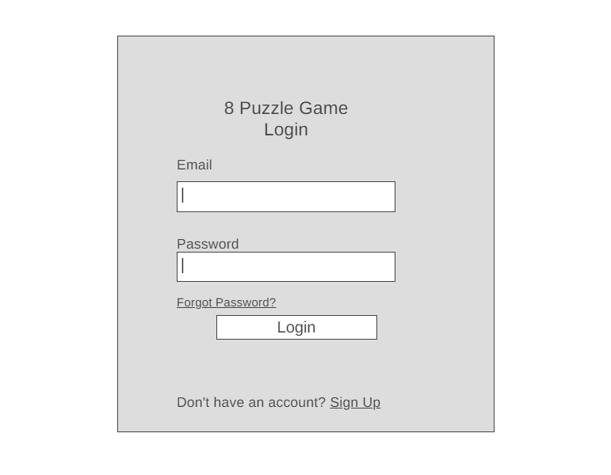
Figure 3. 9: Login Page Design of 8-puzzle Game and Solver
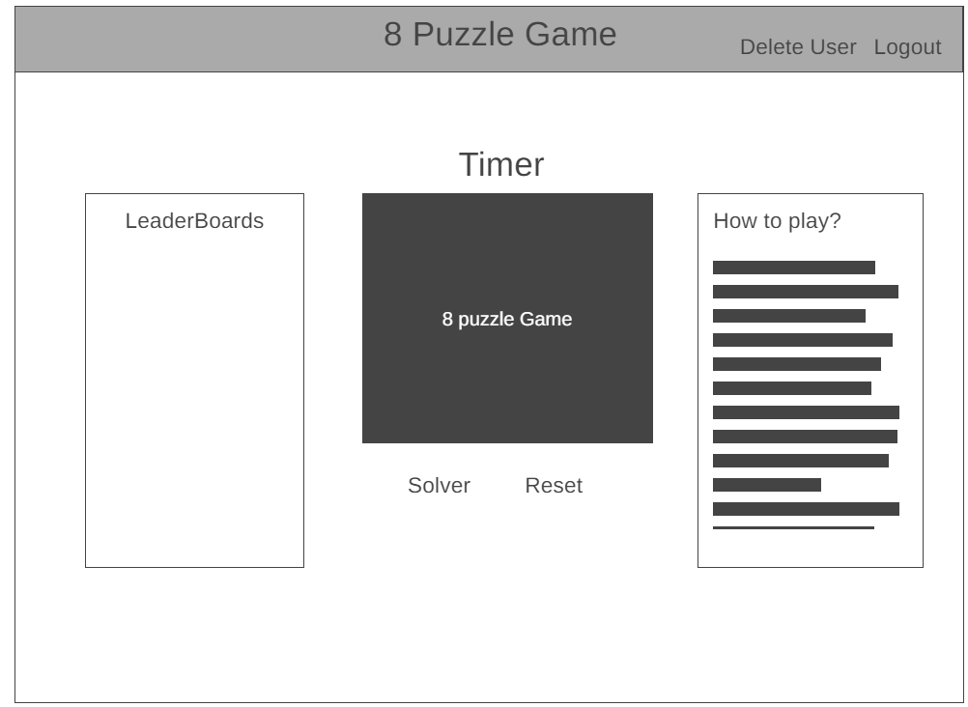
Figure 3. 10: 8-Puzzle Game Design
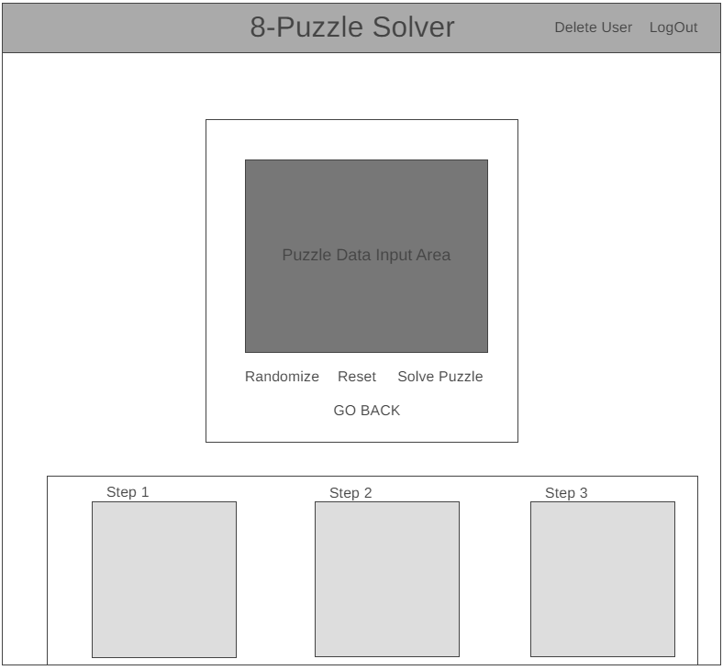
Figure 3. 11: 8-Puzzle Solver Design

3.3 Description of Algorithm
The algorithm for solving the 8-puzzle uses the A* search strategy, combining the cost of reaching the current state with a heuristic estimate of the cost required to reach the goal state. Initially, the algorithm evaluates the current puzzle configuration and generates neighboring states by moving the blank tile to valid adjacent positions. It calculates a score for each state using f(n) = g(n) + h(n), where g(n) represents the number of moves from the initial state and h(n) represents the Manhattan distance from the current state to the goal state. The algorithm maintains an open set of states to be explored and selects the state with the lowest f(n) value for further evaluation. This process continues until the goal state is found or the maximum iteration limit is reached. The step-by-step procedure of the 8-puzzle solver is as follows:
Step 1: The existSolution function checks whether the puzzle configuration is solvable by calculating its inversion count. The blank tile (0) is ignored. If the inversion count is even, the puzzle is considered solvable.
Step 2: When a random puzzle is generated, the system repeatedly generates new permutations until a solvable configuration is obtained.
Step 3: The A* algorithm evaluates each state using f(n) = g(n) + h(n), where g(n) is the number of moves from the initial state to the current state and h(n) is the Manhattan distance from the current state to the goal state.
Step 4: The initial puzzle state is added to the open set. Its initial g(n) value is set to 0, and its f(n) value is calculated using the Manhattan-distance heuristic.
Step 5: During each iteration, the algorithm selects the state with the lowest f(n) value from the open set.
Step 6: If the selected state matches the goal state [1, 2, 3, 4, 5, 6, 7, 8, 0], the algorithm reconstructs the solution path and returns the sequence of puzzle states.
Step 7: If the goal has not been reached, the current state is removed from the open set and added to the closed set.
Step 8: The algorithm generates neighboring states by moving the blank tile (0) to each valid adjacent position: left, right, up, or down.
Step 9: Neighboring states that are already present in the closed set are skipped. For the remaining states, a tentative g(n) value is calculated as the current state's g(n) value plus 1.
Step 10: For each accepted neighboring state, the algorithm records its parent state, updates its g(n) value, and calculates its f(n) value by adding the Manhattan-distance heuristic.
Step 11: The heuristic value h(n) is calculated using the Manhattan-distance heuristic. For each numbered tile, the algorithm identifies the tile's current row and column and its goal row and column. The distance for that tile is calculated as:
|goal row − current row| + |goal column − current column|
The distances of all numbered tiles are then added together to obtain the total h(n) value. The blank tile (0) is excluded from the calculation.
For example, if tile 2 is one position away from its goal position and tile 3 is two position away, while all other tiles are correctly positioned, then:
h(n) = 1 + 2 = 3
Step 12: The search continues until the goal state is found or the maximum iteration limit of 10,000 iterations is reached.
Step 13: If the goal state is found, the reconstructPath function follows the recorded parent states from the goal back to the initial state and produces the complete solution path. The solution is then displayed step by step and animated on the puzzle grid.
Step 14: If the solution is not found before the maximum iteration limit is reached, the system displays a message stating that the solution was not found within the iteration limit.

CHAPTER 4: IMPLEMENTATION AND TESTING

4.1 Implementation

4.1.1 Tools Used
Various tools that have been used in this project is listed below:
i) Visual Studio Code:
Visual Studio Code is a source-code editor used for writing and managing the HTML, CSS, JavaScript, and PHP code used in this project.
ii) XAMPP:
XAMPP is a widely used open-source software package that provides developers with a complete web development environment. It combines Apache, MySQL, PHP, and Perl to create a local server environment for building and testing web applications.
iii) Web Browser:
A web browser is a critical software application that enables users to access and interact with websites on the internet. It interprets HTML, CSS, and JavaScript code to render web pages and provides a user-friendly interface for browsing the internet. Microsoft Edge has been used in this project.

4.1.2 Implementation Details of Modules
Implementing modules in the 8-Puzzle Game and Solver involves developing and integrating specific features and functionalities to enhance efficiency, user experience, and operational aspects of the system. The following key modules are implemented:
- 8-Puzzle Game
This is the primary module where users can engage in playing the 8-Puzzle. The module provides an interactive interface for users to rearrange puzzle pieces to achieve the goal state. Key features within the game module include:
  - Timer: The timer runs continuously while users solve the puzzle. Upon successful completion of the puzzle, the elapsed time is recorded along with the user's username in the database. This feature not only adds a challenge to the game but also tracks performance for competitive rankings.
  - Leaderboard: The leaderboard displays the top 8 players who have completed the puzzle in the shortest time. This competitive feature encourages users to improve their performance, fostering a sense of achievement and community among players.
  - How to Play: A comprehensive guide provides detailed instructions on how to play the puzzle game. It explains the rules and objectives, making it easy for both new and experienced players to understand the gameplay mechanics. This feature ensures that users of all levels can enjoy the puzzle without confusion.
  - Logout: Users can easily log out from the game page at any time, ensuring that their session is terminated securely.
  - Delete Account: Users have the option to delete their account by providing the correct password. This action permanently removes their data from the system, giving users full control over their personal information.
  - Reset: The reset feature allows users to restart the puzzle with a new configuration of tiles. This is useful when users want to challenge themselves with different puzzle data or simply start over after being stuck.
  - Solver: For users who are unable to solve the puzzle or are interested in learning the solution process, the solver feature automatically solves the puzzle using the A* Algorithm. It provides a step-by-step explanation of the solution, making it an excellent learning tool.

- 8-Puzzle Solver
The solver is a powerful feature that uses the A* Algorithm to solve the puzzle and display the steps involved in reaching the solution. This module helps users who are stuck or want to analyze the solution path for educational purposes. The solver module offers the following functionalities:
  - Reset: Clears the current puzzle data, allowing users to input their custom puzzle to be solved. This feature is especially useful for users who wish to test specific configurations and see how the solver tackles different challenges.
  - Generates a random solvable puzzle configuration, allowing users to see the solver in action on a variety of puzzles. This feature adds variety and unpredictability to the puzzle-solving experience, making the game more engaging.
  - Solve Puzzle: The solver computes the solution using the A* Algorithm and presents the steps to the user. Each move is shown sequentially, demonstrating how the puzzle can be solved optimally. This feature is educational as it highlights the logic behind the solution.
  - Go Back: Allows users to return to the main puzzle game page after using the solver. This feature ensures smooth navigation between different modules, improving the user experience.
  - Logout: Users can log out from the solver page, ensuring their session is securely terminated.
  - Delete Account: Similar to the main game page, users can delete their account from the solver module by entering a valid password, thus giving them control over their personal data even while using the solver.

4.2 Testing
Software testing is a crucial phase in software development, guaranteeing that the application operates as envisioned, is devoid of glitches, and aligns with user demands. By methodically assessing and addressing concerns prior to rollout, testing ensures a smooth user journey and overall software dependability. This integral process elevates product quality and user contentment.

4.2.1 Test Case for Unit Testing
Test Case: 1
Table 4. 1 Login Testing
S.no | Test case | Input | Expected result | Actual result | Status
1. | Login | Entering correct login credential i.e., username, password | To enter the 8-Puzzle Page | Didn’t Enter into the page | Failed
2. | Login | Entering correct login credential i.e., username, password | To enter the Puzzle Page | Entered into Puzzle Page | Success

Test Case: 2
Table 4. 2 Register and Forgot Password Testing
S.no | Test case | Input | Expected result | Actual result | Status
1. | Register of user | Entering user credential i.e., email, username, password. | OTP verification and Adding of the user to the database along with its credentials | OTP wasn’t sent to the given email. | Failed
2. | Register of user | Entering user credential i.e., email, username, password. | OTP verification and Adding of the user to the database along with its credentials | OTP was sent to the given email and the user data was added on the database when correct OTP was entered. | Success
3. | Forgot Password | Entering Registered Email, New password and Correct OTP | OTP sent to email address and change of password on the input of correct OTP. | Password Changed Successfully. | Success
4. | Forgot Password | Entering invalid email, which was not registered to the database. | Give error message that the email doesn’t exist | Error Message was not shown. | Failed
5. | Forgot Password | Entering invalid email, which was not registered to the database. | Give error message that the email doesn’t exist | Error Message was shown. | Success

Test Case: 3
Table 4. 3 Puzzle Game Testing
S.no | Test case | Input | Expected result | Actual result | Status
1. | Moving of puzzle tiles. | Clicking the corresponding tile to move to the empty space. | Movement of tile which was pressed. | The tile was moved. | Success
2. | Reset Functionality | Pressing the Reset Button | Solvable puzzle to be shown with even inversion. | Fatal Error is shown. | Failed
3. | Reset Functionality | Pressing the Reset Button | Solvable puzzle to be shown with even inversion | Unsolvable puzzle was shown with odd inversion. | Failed
4. | Reset Functionality | Pressing the Reset Button | Solvable puzzle to be shown with even inversion | Error with inversion calculation | Failed
5. | Reset Functionality | Pressing the Reset Button | Solvable puzzle to be shown with even inversion | Solvable puzzle was shown | Success
6. | Leaderboards | Viewing the leaderboards | List of the top 8 players with the least solve time. | Fatal Error is shown for foreign key constraint failed in timescore. | Failed
7. | Leaderboards | Viewing the leaderboards | List of the top 8 players with the least solve time. | The list showed the players but not in ascending order of time. | Failed
8. | Leaderboards | Viewing the leaderboards | List of the top 8 players with the least solve time. | The List of players in proper order was shown. | Success
9. | Deletion of User | Entering valid password. | Deletion of user | Deletion of user. | Success
10. | Logout | Pressing the Logout Button. | Destruction of Session and redirect to Login | Destruction of Session and redirect to Login. | Success
11. | Solve Puzzle | Solving the puzzle | Alert Stating the puzzle was solved, and time taken to solve it | Alert didn’t popup. | Failed
12. | Solve Puzzle | Solving the puzzle | Alert Stating the puzzle was solved, and time taken to solve it | Alert popup worked. | Success
13. | Timer | Viewing the timer | Timer gradually increasing accurately. | Time increase accurately. | Success

Test Case: 4
Table 4. 4 Solver Testing
S.no | Test case | Input | Expected result | Actual result | Status
1. | Data Validation Check | Entering duplicate and invalid numbers | Error about duplicate and invalid number | No Error was shown | Failed
2. | Data Validation Check | Entering duplicate and invalid numbers | Error about duplicate and invalid number | Error shown only about the invalid number | Failed
3. | Data Validation Check | Entering duplicate and invalid numbers | Error about duplicate and invalid number | Error about duplicate and invalid number | Success
4. | Reset Functionality | Click Reset Button | Clear the data inside the solver | Clear the data inside the solver | Success
5. | Randomize Functionality | Click Randomize Button | Give solvable set of random numbers with even inversion. | Numbers weren’t generated | Failed
6. | Randomize Functionality | Click Randomize Button | Give solvable set of random numbers with even inversion. | Random number was generated but wasn’t solvable | Failed
7. | Randomize Functionality | Click Randomize Button | Give solvable set of random numbers with even inversion. | Solvable set of random numbers were shown. | Success
8. | Solve Puzzle | Click on the Solve Button | Solve the puzzle | Error was displayed. | Failed
9. | Solve Puzzle | Click on the Solve Button | Solve the puzzle | The Puzzle was Solved | Success
10. | Solution Visualization | Click on the Solve Button | Solution Steps was shown | Solution Steps was shown | Success

4.2.2 Test Case For System Testing
Test Case: 5
Table 4. 5: System Testing
S.no | Test case | Input | Expected result | Actual result | Status
1. | Transfer of puzzle data from puzzle to solver. | Clicking the Solve Button | Puzzle values transfer puzzle to solver | The puzzle Array didn’t transfer. | Failed
2. | Transfer of puzzle data from puzzle to solver. | Clicking the Solve Button | Puzzle values transfer puzzle to solver | The puzzle Array got transferred. | Success
3. | Transfer of email from login to the puzzle via Session | Logged in using respective credentials | Email Passed via session | Email Passed via session | Success

CHAPTER 5: CONCLUSION AND FUTURE RECOMMENDATIONS

5.1 Conclusion
The 8-Puzzle Game and Solver is an online tool designed to challenge users with solving the classic 8-puzzle game while also providing an efficient solution through an algorithmic solver. The platform allows users to engage with the puzzle, and offers a step-by-step guide using the A* algorithm for when they require assistance. The main aim of this project is to provide both entertainment and education, helping users improve their problem-solving skills while understanding algorithmic approaches to puzzles, thereby making the process both engaging and informative.

5.2 Lesson Learned
This project provided valuable insights into the development of the 8-Puzzle Game and Solver, as well as how each module interacts to form a cohesive system. It highlighted how various features complement one another, contributing to the overall functionality and success of the project. Some of the key lessons learned during the development of this project include:
- Understanding algorithms: Gained in-depth knowledge about the A* Algorithm and how it can be applied to solve complex problems like the 8-Puzzle.
- User interface design: Developed skills in creating intuitive and user-friendly interfaces for puzzle games.
- Learning about testing: Implemented various testing methods to ensure the game and solver modules function correctly under different conditions.
- Integration of various features: Discovered how different modules, such as the game, solver, and leaderboard, integrate seamlessly to enhance the user experience.
- Maintaining documentation: Learned the importance of maintaining comprehensive documentation to ensure future maintenance and scalability of the project

5.3 Future Recommendations
  - Integration of more complicated puzzles like 15 Puzzle.
  - Adding hint feature that can suggest optimal moves or strategies to help users improve their problem-solving skills without relying entirely on the solver.
  - Adding responsive mobile view Feature.

REFERENCE

[1] | C. M. Yang, V. Pek, S. H. Ling, T. C. Wei and Z. A. A. Salam, "Solver of 8-Puzzle with Genetic Algorithm," Journal of Applied Technology and Innovation, vol. 7, no. 1, pp. 28-32, 1 March 2023.
[2] | A. Reinefeld, "Complete Solution of the Eight-Puzzle and the Benefit of Node Ordering in IDA*," in Thirteenth International Joint Conference on Artificial Intelligence, Chambéry, France, 1993.
[3] | V. Menon, G. B. Amali.D, G. Gopichand, H. Santhi and P. Gayatri, "Performance Analysis of Various Uninformed and Informed Search Strategies on 8 Puzzle Problems - A Case Study," World Wide Journal of Multidisciplinary Research and Development, vol. 4, no. 12, pp. 96-99, 2018.

APPENDICES
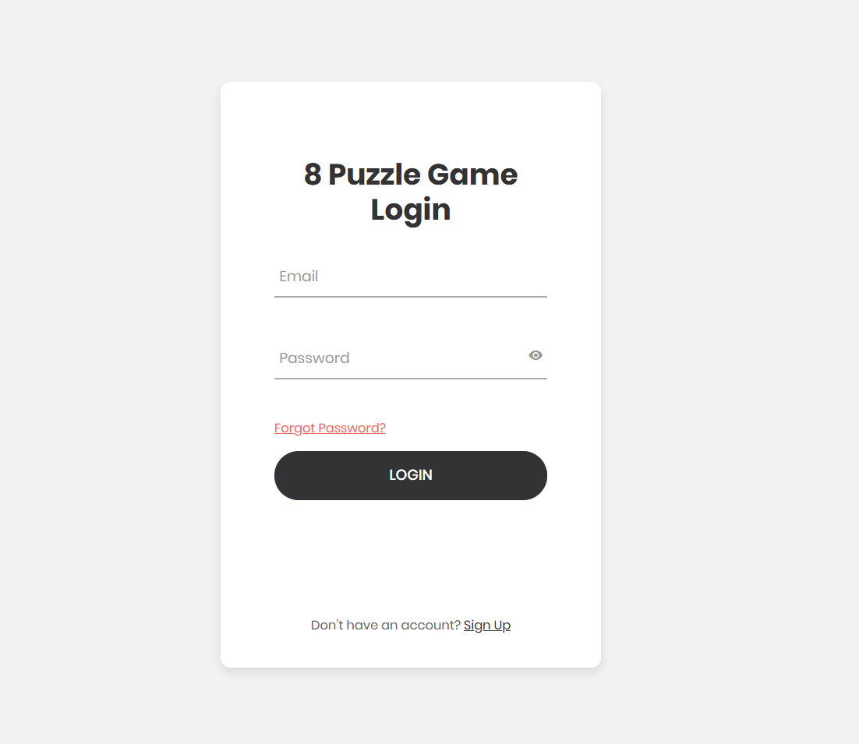

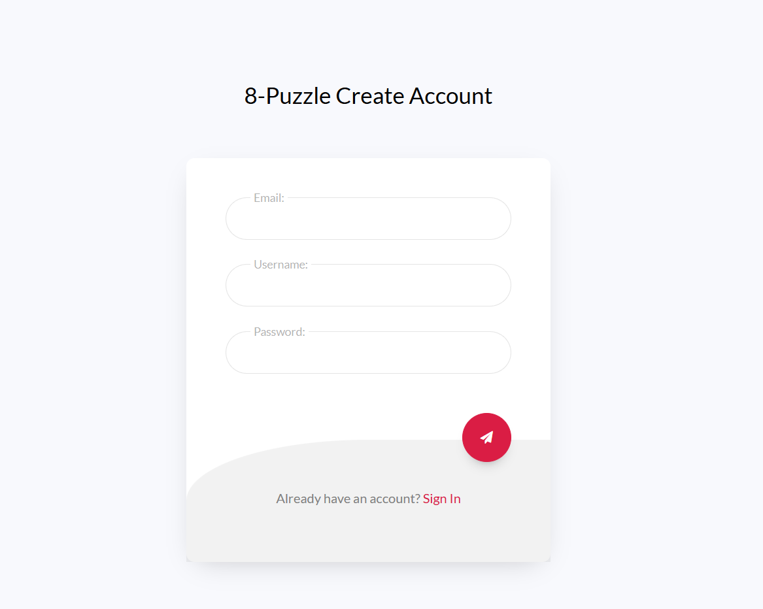
Figure 1: Login Page

Figure 2: Register Page
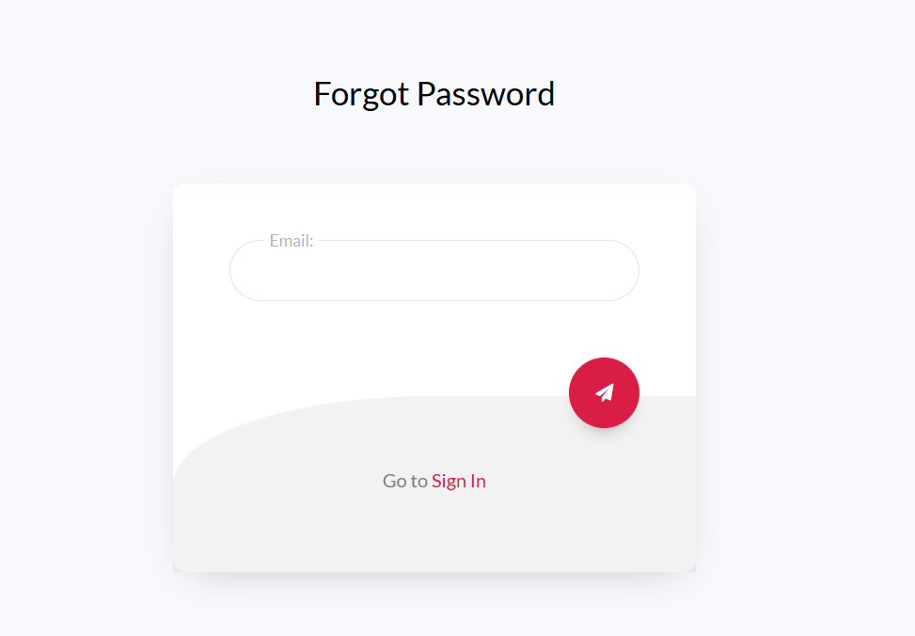

Figure 3: Forgot Password Page

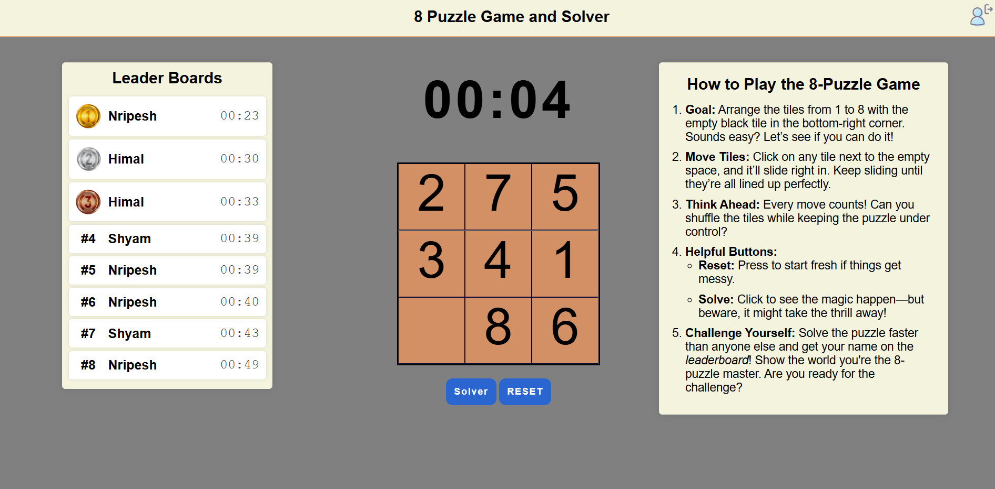
Figure 4: 8-Puzzle Page
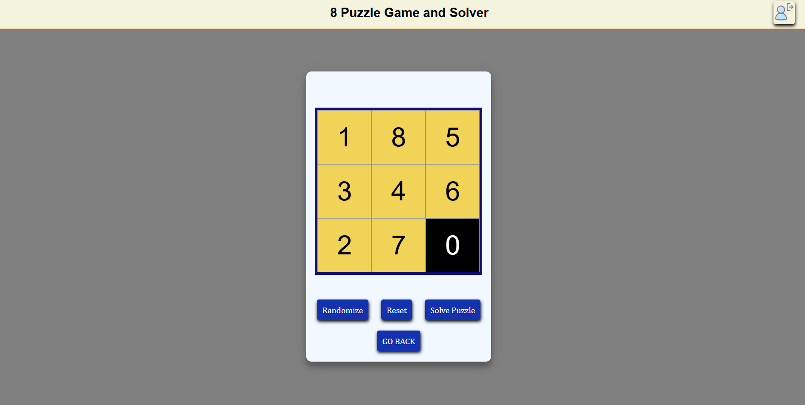
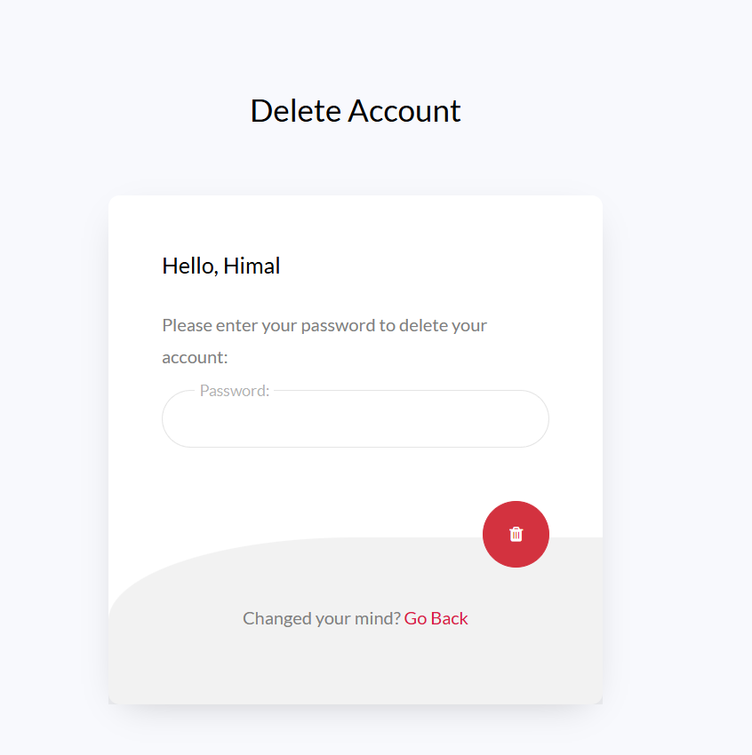
Figure 5: Puzzle Solver Page

Figure 6: Puzzle Solver Page

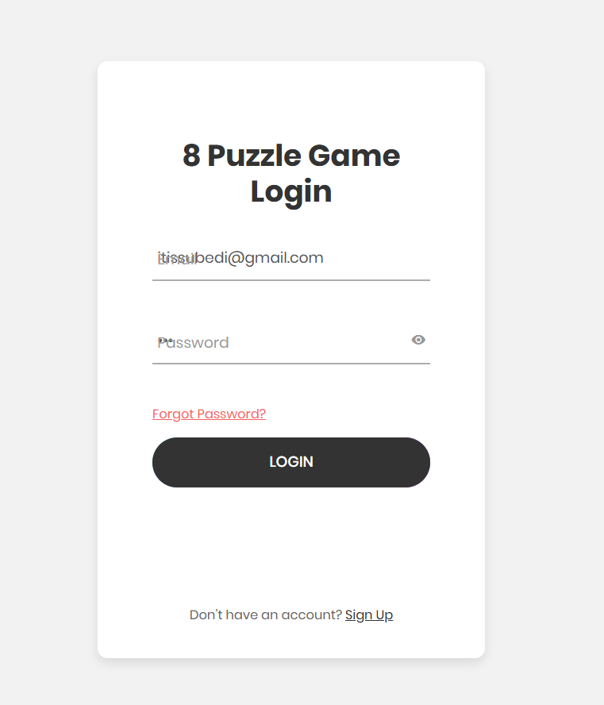

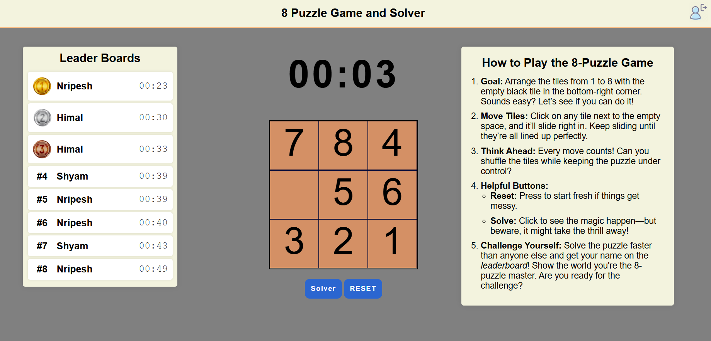
Figure 7: Test Case for Login

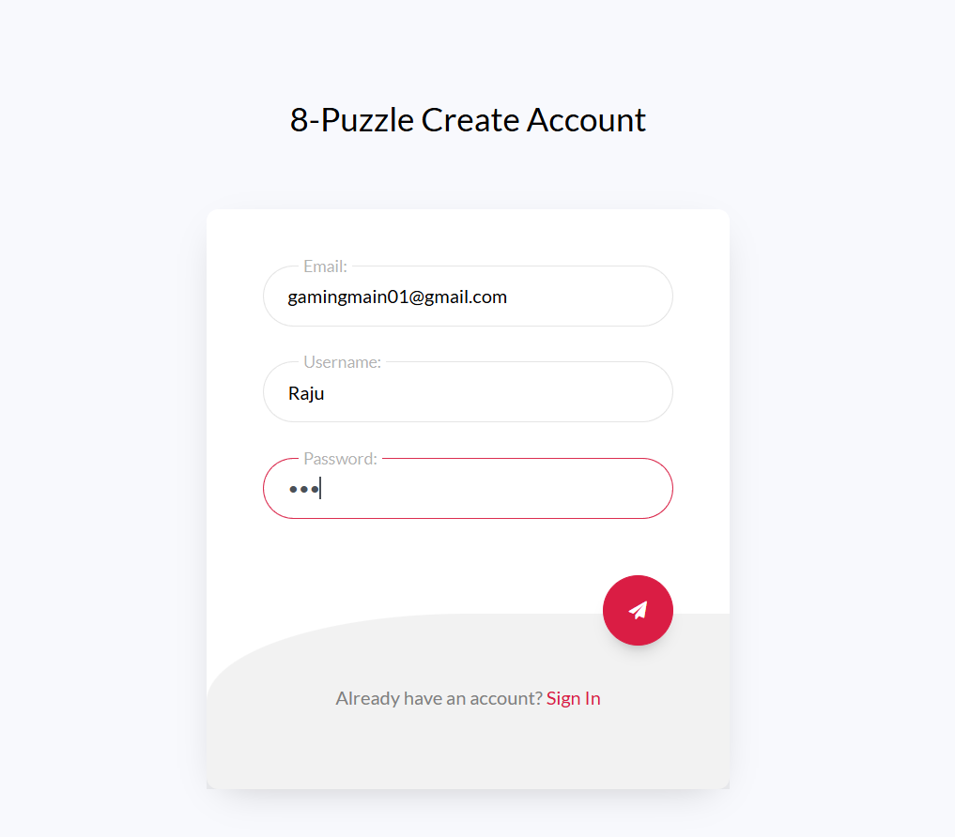

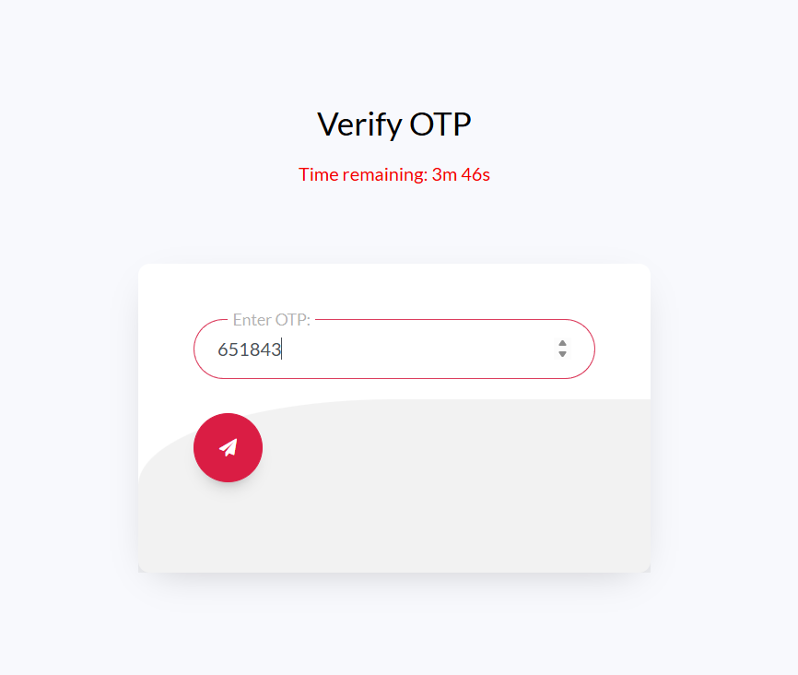
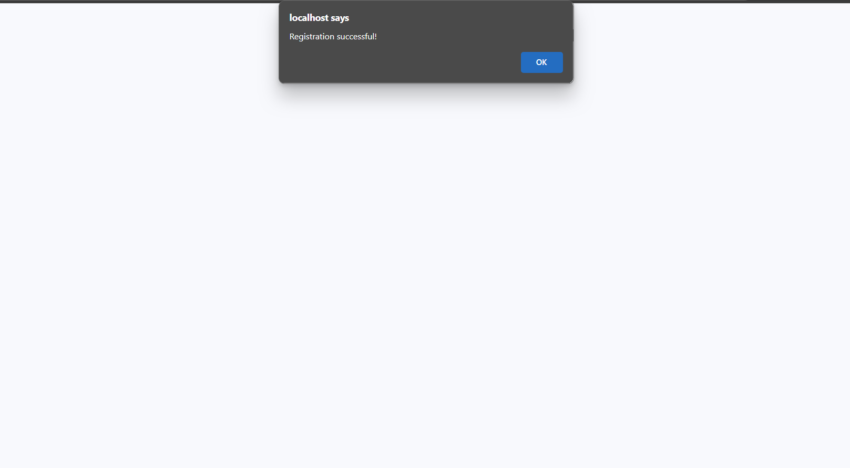
Figure 8: Test Case for Register User
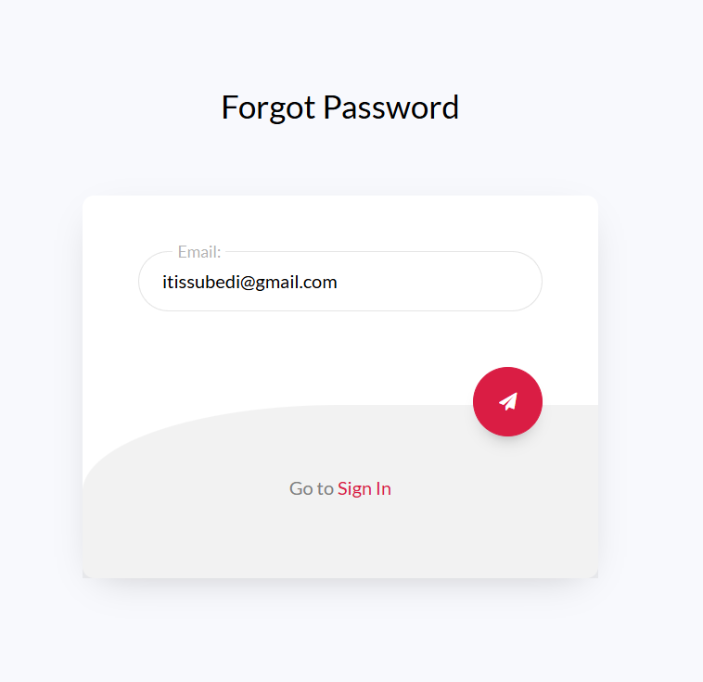
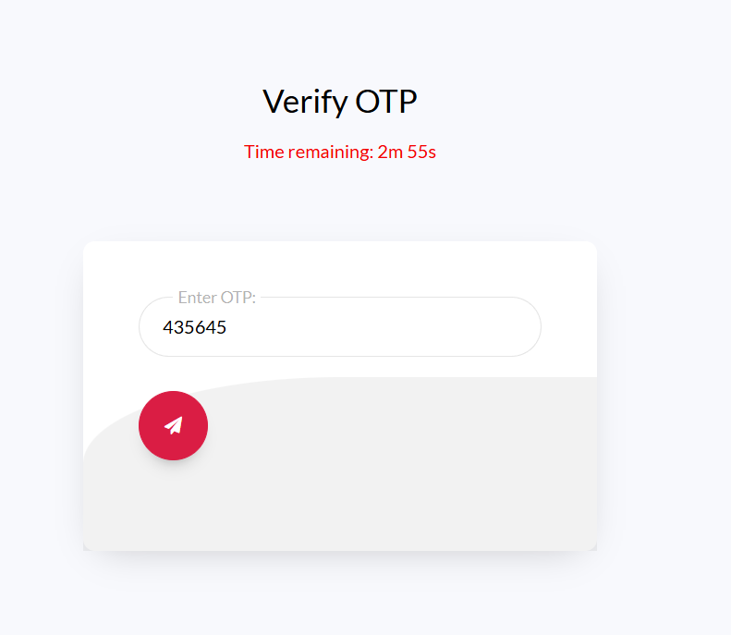
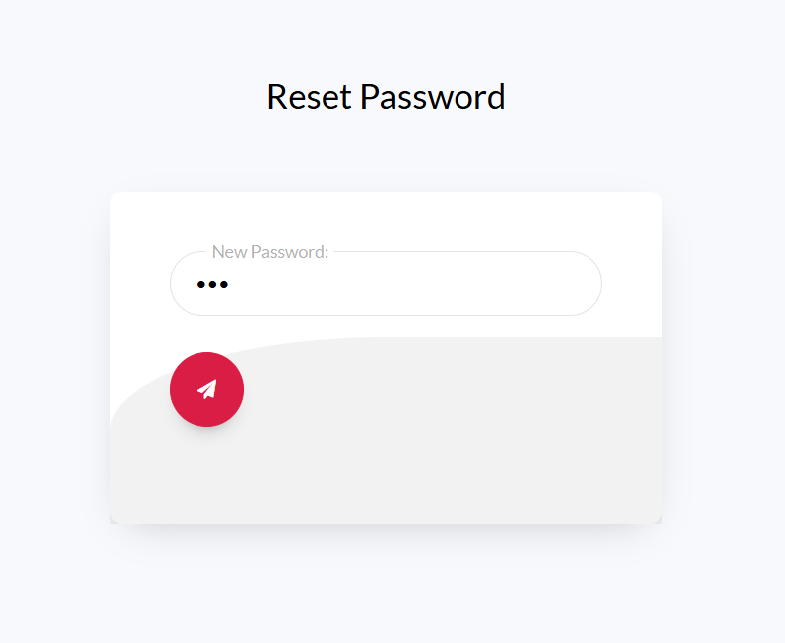
Figure 9: Test Case for Forgot Password
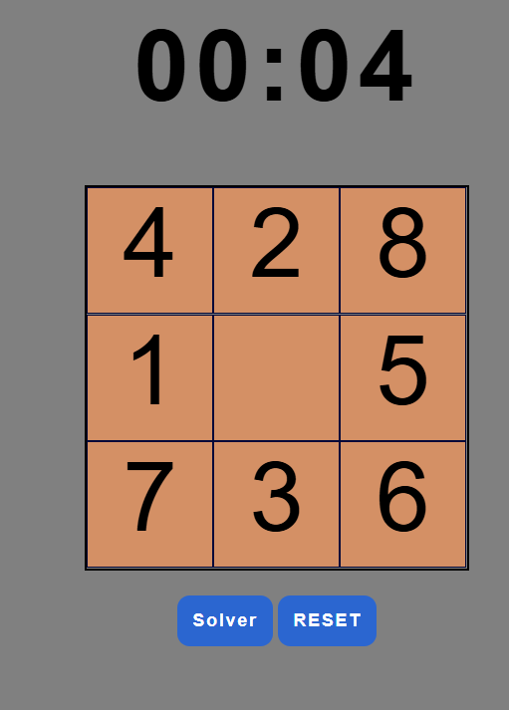
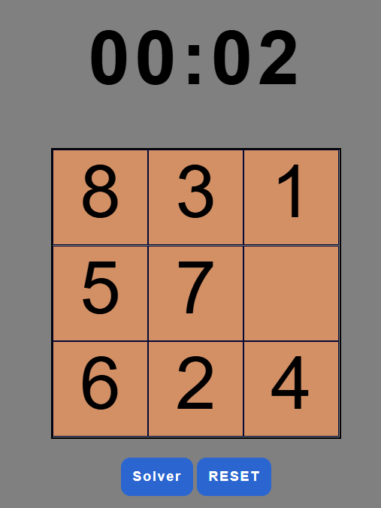
Figure 10: Test Case for Reset Functionality
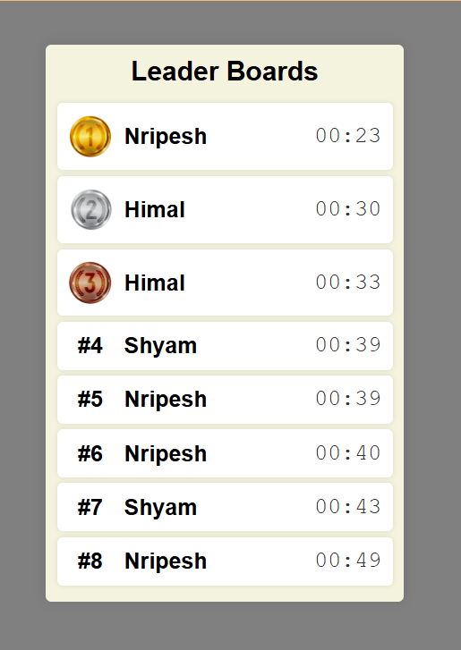
Figure 11: Test Case for Leaderboards
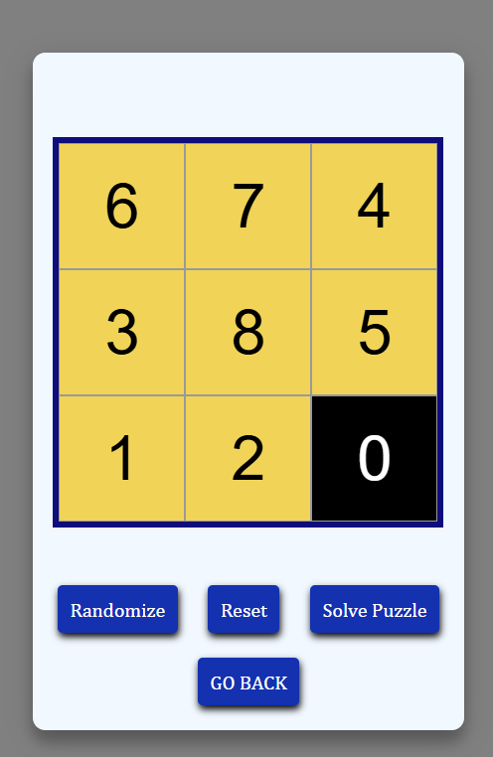
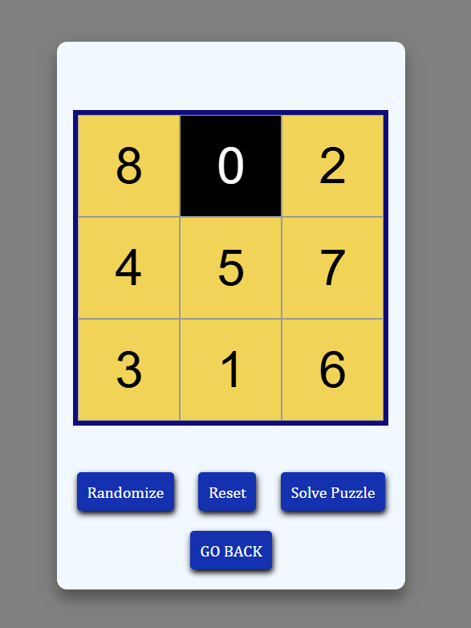
Figure 12: Test Case for Randomize Button

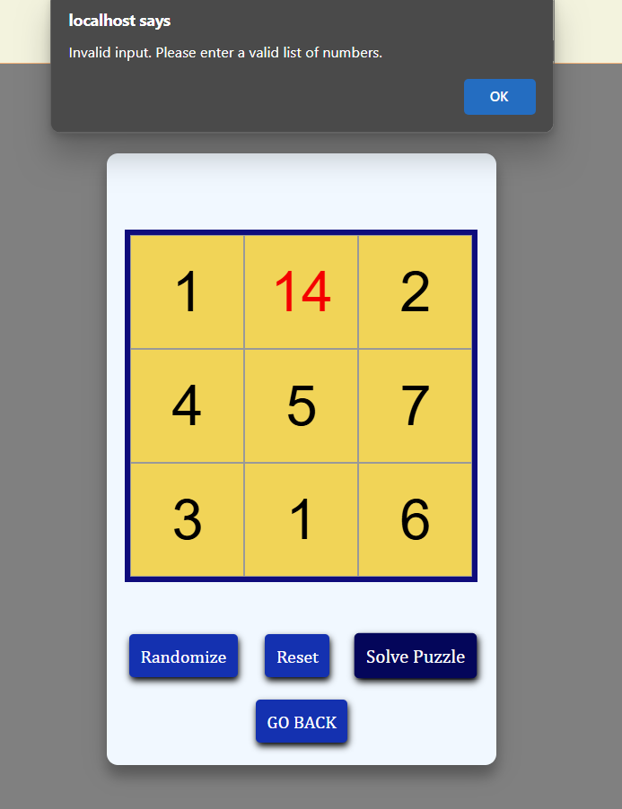

Figure 13: Test Case for Invalid and Duplicate input
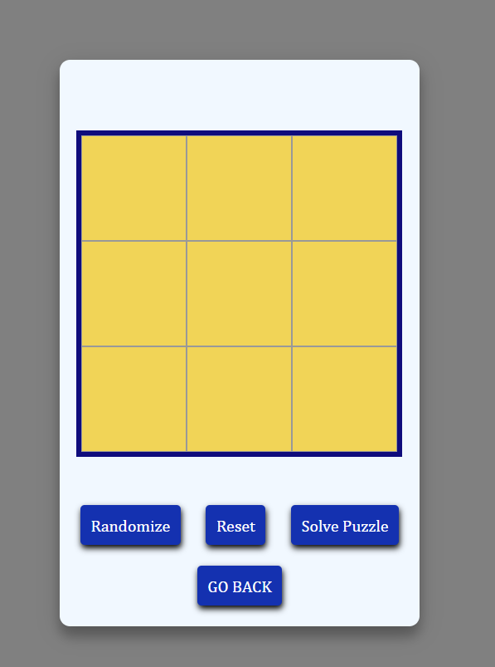

Figure 14: Test Case for Reset Button
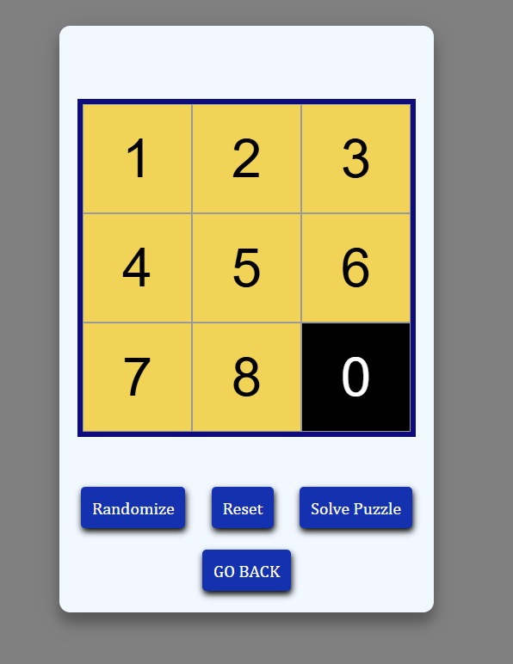
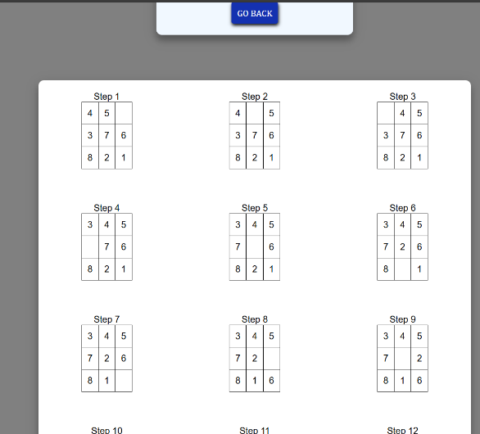
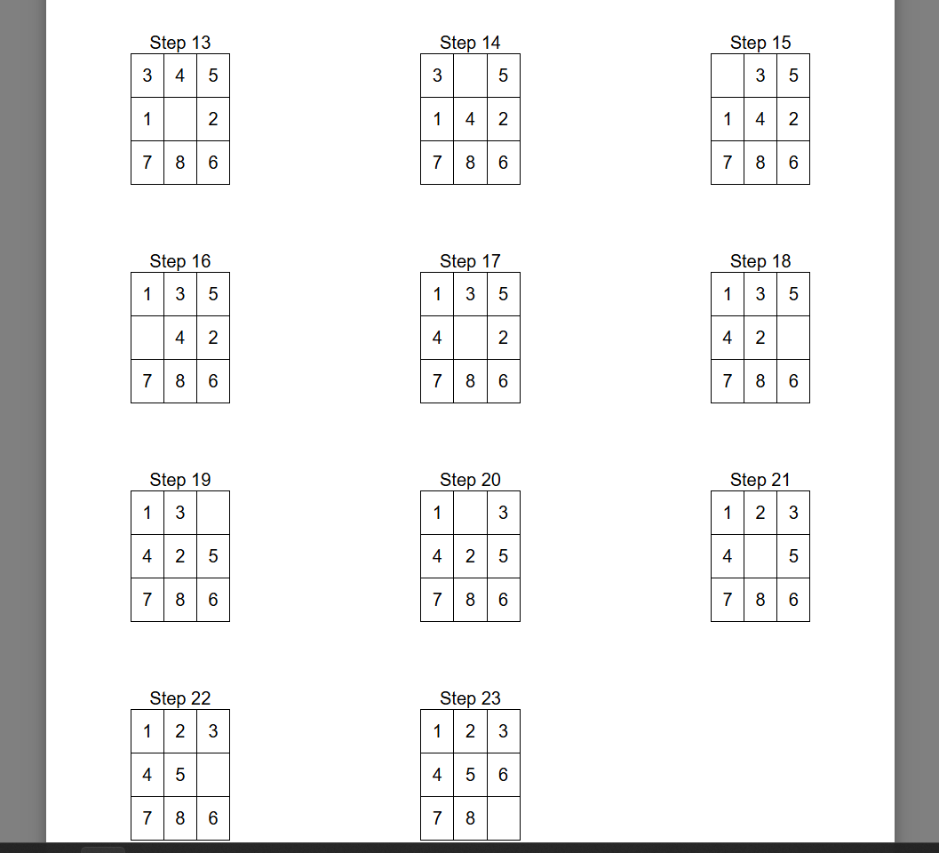
Figure 15: Test Case for Solution and Solution Visualization
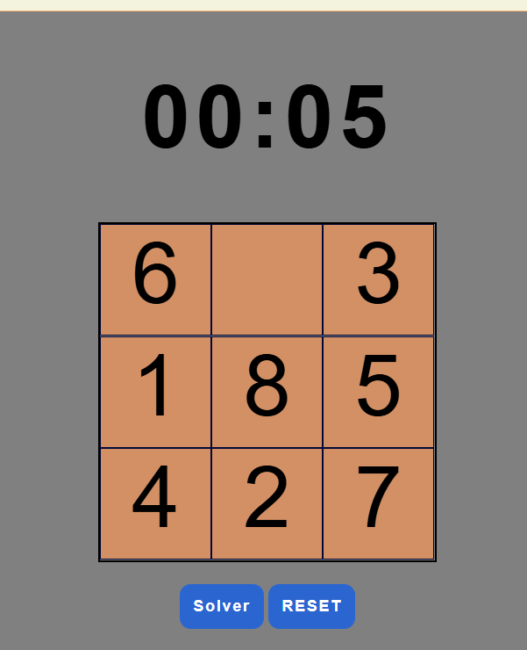
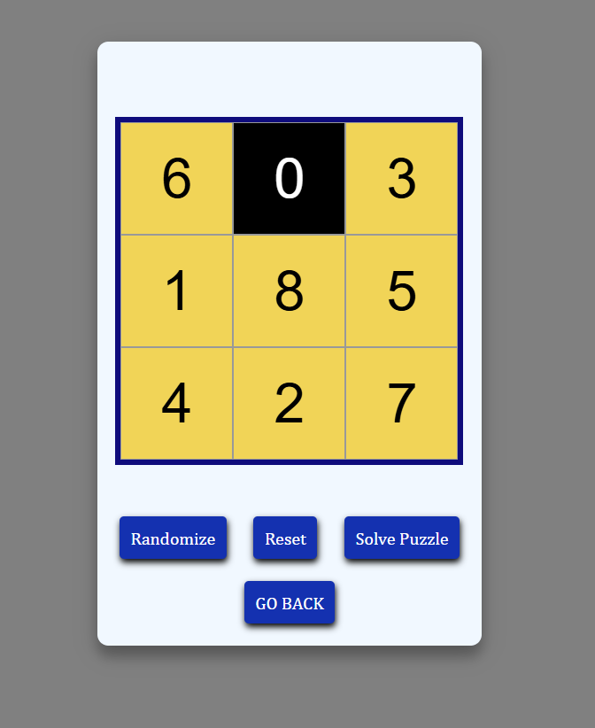
Figure 16: Test Case for Data Transfer from Puzzle to Solver

